# Desktop Virtual Voice Assistant Using Python

Submitted in partial fulfillment of the requirements of the degree

**BACHELOR OF ENGINEERING** IN **COMPUTER ENGINEERING**

By

*Bhabal Rohan Ravindra (312010)*

*Bijapur Azim Ahmed Muktar Ahmed (312011)*

*Khan Arkaan Faizad (312021)*

*Shaikh Abuzar Hafizuddin (312041)*

Name of the Mentor

**Prof.Anand Bali**



**Department of Computer Engineering**

**M.H.Saboo Siddik College of Engineering**

**(AY 2021-2022)**

8, Saboo Siddik Polytechnic Road, Byculla Mumbai Maharashtra 400008

# CERTIFICATE

This is to certify that the Mini Project entitled **“Desktop Virtual Voice Assistant Using Python”** is a bonafide work of **Bhabal Rohan Ravindra (312010), Bijapur Azim Ahmed Muktar Ahmed (312011), Khan Arkaan Faizad (312021) and Shaikh Abuzar Hafizuddin(312041)** submitted to the University of Mumbai in partial fulfillment of the requirement for the award of the degree of **“Second Year Bachelor of Engineering”** in **“Computer Engineering” .**

## (Prof. Anand Bali)

Mentor

## (Dr.Zainab Pirani) (Dr. Ganesh Kame)

Head of Department Principal

# Mini Project Approval

This Mini Project entitled “**Desktop Virtual Voice Assistant Using Python”** by **Bhabal Rohan Ravindra (312010), Bijapur Azim Ahmed Muktar Ahmed (312011), Khan Arkaan Faizad (312021) and Shaikh Abuzar Hafizuddin(312041)** is approved for the degree of **Bachelor of Engineering** in **Computer Engineering.**

**Examiners**

**1………………………………………**

(Internal Examiner Name & Sign)

## 2…………………………………………

(External Examiner name & Sign)

Date: Place:

***Abstract:***

*This project aims in developing a personal virtual assistant for PCs which can accept voice commands and convert them into computer understandable language and then execute those tasks asked by user. It is user friendly and the commands defined in it can be modified and added according to the need of the user. As a personal assistant, this application is capable of performing day to day tasks such as: sending emails, playing music, opening code editors or MS Office applications, opening YouTube or Google, searching on Wikipedia, etc. This app does not use machine learning and AI, it is programmed using python. But it can be further enhanced using machine learning algorithms. This application can be run in nearly any OS with some modifications so it is quite beneficial for Linux users as well, as they don’t have an inbuilt assistant. A drawback of the virtual assistants like Google Assistant, Alexa etc. is that they tend to store vital information of users which is intrusion of privacy but this assistant is quite safe in that respect.*

i

**ACKNOWLEDGEMENT**

The success of this project work required a lot of guidance and assistance from many people and I am extremely fortunate to have got this all along the completion of my project work. Whatever I have done is only due to their guidance and assistance. I thank Principal **DR. GANESH KAME** and Head of the Department (H.O.D**) DR. ZAINAB PIRANI** for giving me an opportunity to participate in this project work in **M. H. SABOO SIDDIK COLLEGE OF ENGINEERING** and providing me all the support and guidance which made me complete the project on time. I am extremely grateful to him for supporting us though he had a busy schedule managing the organizational affairs. I owe my profound gratitude to our project guide **PROF. ANAND BALI**, who took keen interest in our project work and guided us till the completion of our project by providing us all the necessary information for developing a good application I am fortunate enough to get constant encouragement, support and guidance from all Teaching staffs of Department of computer science who helped us in successfully completing our project work. I would also like to extend our sincere regards to all the non-teaching staff of department of computer science for their timely support.

ii

# Contents

## Abstract i

## Acknowledgments ii

## Introduction 1

* 1. Introduction
  2. Motivation
  3. Problem Statement & Objectives

1. **Literature Survey 4**

## Proposed System 7

* 1. Architecture/ Framework
  2. Algorithm and Process Design
  3. Details of Hardware & Software

1. **Conclusion and Future scope 11**

**4.1** Time Line

* 1. Future Work
  2. Conclusion

## References 13

1. **Introduction**

Personal assistants have become popular these days. Siri, Alexa, Google assistant are some of the most used assistants used by the people. It is all because of the features and efficiency they provide. Features like making calls, sending emails, opening system applications, taking photographs, asking questions or doubts, browsing internet etc., are automated by personal assistants. So, utilization of these features of a virtual assistant will save an individual a lot of time, and effort. People often spend more time on doing routine tasks, and they can be automated with these types of personal assistants.

In this project we have designed a desktop virtual voice assistant using python and its modules. We have named it Alex (just for fun to call it: younger brother of Alexa). User is expected to just give a voice command and the assistant will execute those tasks. The application uses the microphone as the source to receive the audio input and it then converts the speech to text query which is then fed to our functions which then perform the required task using different modules. Mainly we can classify these commands into three types: web related, system related and questions. Here we intend to include all these types in our application. We have aimed to automate all the day to day life tasks that user needs to perform so as he can save time and be more efficient at work. The application does not use AI and Machine Learning but we look forward to make it better by adding GUI and AI and ML features to it in upcoming semesters.

**1**

* 1. **Motivation:**

We have many voice assistant in the market like Google assistant, Alexa etc. But a dark side of these assistants is that they tend to store user’s data and use system mic continuously which may lead to cyber threats. Our main motivation is to program a personalized voice assistant for automating the desktop which will be more secure and all its functioning will be in the hands of the user. It will help the user to access nearly each and every useful file and application in the system .So this program is capable of functioning without internet connectivity for queries related to the system which other assistant like Alexa are not able to do. It is also platform independent and can be run in any OS with slight modifications.

* 1. **Problem Statements:**

To create a personalized desktop virtual voice assistant for increasing the efficiency at work which can be modified according to the needs of user.

* 1. **Objectives:**

To program a virtual voice assistant for desktop which is platform independent and can perform the following day to day task of user thereby increasing the efficiency at work and saving more time:

**2**

* *sending emails*
* *playing music,*
* *opening code editors*
* *opening MS Office applications*
* *opening YouTube*
* *opening folders*
* *opening Google*
* *searching on Wikipedia*
* *getting the weather news*

**3**

**2. Literature Survey**

The birth of the first virtual assistant; however, began with IBM Simon in the early 1990s. It was a digital speech recognition technology that became a feature of the personal computer with IBM and Philips.

Many companies have used the dialogue systems technology to establish various kinds of Virtual Personal Assistants(VPAs) based on their applications and areas, such as Microsoft's Cortana, Apple's Siri, Amazon Alexa, Google Assistant, and Facebook's M. However, in this proposal, we have used the multi-modal dialogue

systems which process two or more combined user input modes, such as speech, image, video, touch, manual gestures, gaze, and head and body movement in order to design the Next-Generation of VPAs model. The new model of VPAs will be used to increase the interaction between humans and the machines by using different

technologies, such as gesture recognition, image/video recognition, speech recognition, the vast dialogue and

**4**

conversational knowledge base, and the general knowledge base [Kepuska, V., Bohouta, G. “Next generation of Virtual Personal Assistants (Microsoft Cortana, Apple Siri, Amazon Alexa and Google Home)”. IEEE Conference (2018).].

The Most famous application of iPhone is “SIRI” which helps the end user to communicate end user mobile with voice and it also responds to the voice commands of the user. Same kind of application is also developed by the Google that is “Google Voice Search” which is used for in Android Phones. But this Application mostly works with Internet Connections. But our Proposed System has capability to work with and without Internet Connectivity. It is named as Personal Assistant with Voice Recognition Intelligence, which takes the user

input in form of voice or text and process it and returns

the output in various forms like action to be performed or the search result is dictated to the end user. In addition, this proposed system can change the way of interactions between end user and the mobile devices.

**5**

The system is being designed in such a way that all the

services provided by the mobile devices are accessible by the end user on the user's voice commands[Dr. Kulhalli K, Dr. Sirbi K, Mr. Patankar A. (2017). “Personal Assistant with Voice Recognition Intelligence”. Int. Journal of Engineering Research and Technology. Vol. 10 (No. 1) (pp. 416-419), International Research Publication House.].

Voice control is a major growing feature that change the

way people can live. The voice assistant is commonly being used in smartphones and laptops. AI-based Voice assistants are the operating systems that can recognize human voice and respond via integrated voices. This voice assistant will gather the audio from the microphone and then convert that into text, later it is sent through GTTS (Google text to speech). GTTS engine will convert text into audio file in English language, then

that audio is played using play sound package of python

programming Language[Subhash S, Prajwal N Srivatsa, Siddesh S, Ullas A, Santhosh B “Artificial Intelligence-Based Voice Assistant” (pp. 593-596). IEEE Conference, (2020).].

He proposed the idea to design a tool that will be used

**6**

to test and compare commercial speech recognition systems, such as Microsoft Speech API and Google Speech API, with open-source speech recognition systems such as Sphinx-4. [G. Bohouta, V. Z. Këpuska, "Comparing Speech Recognition Systems (Microsoft API Google API)", Int. Journal of Engineering Research and Application (2017)]

**3. Proposed System**

**3.1 Details of Hardware & Software:**

* **Hardware Requirements:**
* x86 64-bit CPU (Intel / AMD architecture)
* 4GB RAM
* 5 GB Disk Space
* **Software Requirements:**
* Windows 7 or 10
* Mac OS X 10.11 or higher
* Linux: RHEL 6/7
* Python 3.10.0

**7**

* Visual Studio Code (IDE)
* Important Python Modules like:
* pyttsx3 (converts text to speech)
* speech recognition (converts speech to text )
* sapi5 (software development kit by Microsoft )
* datetime(to get the current time )
* Wikipedia (to access Wikipedia and search queries on it)
* webbrowser (to access other websites)
* os (to interact with the operating system)

**3.2 Architecture:**

The assistant design consists of the following phases:[7]

Speech recognition

Speech to text

Analysis and execution of the command

* The first thing the application does after being run is to listen to the commands. We declare in our program a takeCommand() function which makes

**8**

use of Speech Recognition module to recognize the speech and convert it into a query string. This query is then fed to other functions which then execute the commands. To enable the application take commands, we put all the functions (used else if for

each) in an infinite while loop. [5]

* We also need our assistant to speak. So for this we

use a speak() function. In order to make it speak

something we must give it a text. This text is then converted to speech using pyttsx3 module. pyttsx3 engine is capable of converting text to speech and a say() function in it helps to speak whatever is being fed to it. We also need voices for our program which is given by a software development kit developed by Microsoft called ‘sapi5’ which uses system voices for the purpose. There is a male voice and a female voice in the system which can be selected.[5]

* For the execution of commands, we have used many functions which can be largely classified into two sections: web related and system related. The web related commands mainly use modules like

**9**

* ‘webbrowser’ and ‘wikipedia’ for accessing the

web while the system commands mainly use modules like ‘datetime’ and ‘os’. ‘datetime’ module being for getting the time and ‘os’ being for

interacting with the operating system of user e.g. :

opening a folder or application in users pc.

**3.3Algorithm and Process Design:**

Start

Wait for a query from user

If

Execute the command

Execute query

Good Bye

**Command Question**

**Quit**

**10**

**4. Conclusion and Future work**

**4.1.Timeline:**

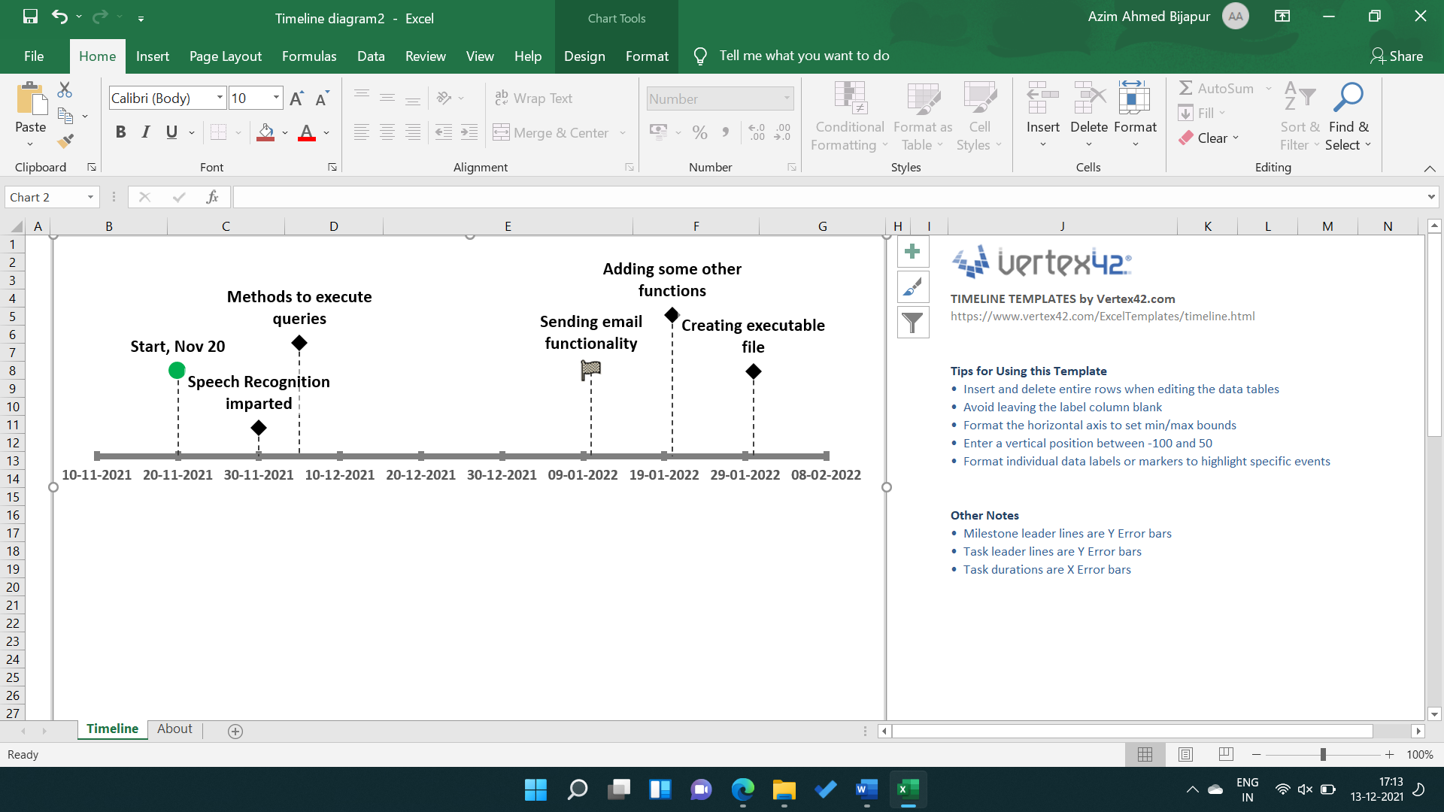

**4.2.Future Work :**

What we have at the present is only a program that when run from the IDE would become our voice assistant. So in the future we may add some GUI for the user using python libraries like Kivy or Tkinter in order to make the assistant look more attractive and for ease of use of the user. We would create its runnable file at the desktop using ‘pyinstaller’ so as the user will be able to access it from the desktop itself. Also, for editing, adding or deleting a command a user needs to change the code in the program which makes it suitable only for programmers. So, we intend to add some features in GUI to manage those commands directly without any need of accessing its code.

**11**

**4.3.Conclusion :**

In this paper we have presented the design and implementation of a virtual desktop assistant “Alex” which will be programmed merely using python. Using this application, we will be able to automate our desktop, access some important sites on the web and also ask queries to the assistant which it will answer referring to the Wikipedia. In short, this assistant will help us in being more productive at work and save time.

**12**

**References:**

[1]Code with Harry – YouTube (<https://www.youtube.com/channel/UCeVMnSShP_Iviwkknt83cww> )

[2] <https://extrudesign.com/virtual-assistant-using-python/>

[3] Ravikumar , Prateek , Sathvik Bhandar, Rahul Kumar, Mayura D Tapkire “virtual voice assistant”,International Research Journal of Engineering and Technology(2020)

[4]Python Documentation

**13**